**3.1.6.2 WIP Gross Profit Summary**

# Purpose:

The purpose of this screen is to let the Agency, Broker or Principal user create the WIP progress history details by entering the contract data for the system to review the WIP details and help in the underwriting process of the bond request.

# Page Activation:

Pro Tools URL: <http://www.xenexhost.com:10080/Protools/index.jsp?agencyId=1&agencyBranchId=1>

**Agency User**

**Existing Account**: Login > Search or Inbox > Click on Company Name > WIP > Gross Profit Summary

**Carrier Underwriter**

**Existing Account**: Login > Bond Manager > WIP > Gross Profit Summary

# Page Security:

This screen is accessible to the Agent and Carrier Underwriters users ONLY

# Screen Images

Agent and Carrier Underwriters view ONLY: Gross Profit Summary screen (as in summary tab of the WIP excel document sent by Mike)

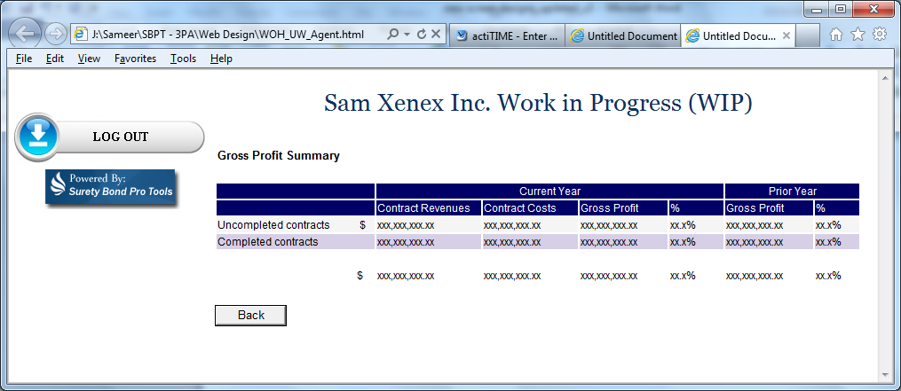

# Page Tabs and Menus

Please refer to the functional decomposition to follow the Tabs and Menus

# General Information:

Please refer the .css (style sheet) document for page and font styling

Please refer to the Pro Tools Contract Bond flow document to understand the business logic and the workflow for agency Sign-Up and Bond request applications.

# 7 Page Controls:

Please see following tables for details on page controls.

| Page Controls  Legend: Mandatory/Optional Column: D = Display Only, M = Mandatory Entry, O = Optional Entry, N = Not Visible | | | | | | |
| --- | --- | --- | --- | --- | --- | --- |
| Label | Control Type | Tab Order | Enabled | Mandatory / Optional | Database Column Name | Validation Criteria / Notes |
| Powered By: Surety Bond Pro Tools | **Image** |  | Y | D |  | **Type:** Image  Left aligned (left navigation image panel section) |
| Logout | **Image** |  | Y | D |  | **Type:** Image  Left aligned (left navigation image panel section)  Refer to Section 8 – Buttons and Action Links |
| <Account Name> Work in Progress (WIP) | **Label** |  | Y | D |  | Display the Account Name followed by the label  **CSS:** style Header 3 (h3) |
| Gross Profit Summary | **Label** |  | Y | D |  | **CSS:** style= Header 5 (H5) |
| Data Display Grid | | | | | |  |
| Current Year | **Label** |  | Y | D |  | **Type: Label**  **CSS:** style = TblHeader |
| Contract Revenues | **Data Grid** |  | Y | D |  | **Type: Data Grid**  Refer to Section 9 – Data Grid |
| Contract Costs | **Data Grid** |  | Y | D |  | **Type: Data Grid**  Refer to Section 9 – Data Grid |
| Gross Profit | **Data Grid** |  | Y | D |  | **Type: Data Grid**  Refer to Section 9 – Data Grid |
| % | **Data Grid** |  | Y | D |  | **Type: Data Grid**  Refer to Section 9 – Data Grid |
| Prior Year | **Label** |  | Y | D |  | **Type: Label**  **CSS: style = TblHeader** |
| Gross Profit | **Data Grid** |  | Y | D |  | **Type: Data Grid**  Refer to Section 9 – Data Grid |
| % | **Data Grid** |  | Y | D |  | **Type: Data Grid**  Refer to Section 9 – Data Grid |
| Uncompleted Contracts | **Data Grid** |  | Y | D |  | **Type: Data Grid**  Refer to Section 9 – Data Grid |
| Completed Contracts | **Data Grid** |  | Y | D |  | **Type: Data Grid**  Refer to Section 9 – Data Grid |
| Back | **Button** | 1 | Y | D |  | **Type:** Button  Refer to Section 8 – Buttons and Action Links |

# Buttons and Action Links

| **Name** | **Action to be taken** |
| --- | --- |
| Back | **Type:** Button  **Function:** The **Back** button will take the user back to the screen where the user clicked the link to come to this screen  **Position:** **Back** button will be positioned at the bottom left of the screen  **Appearance:** General HTML button  **Security/privileges**:Refer to Section 3 - Page Security  **Edits:** N/A  **Go to:** The system will take the user back to the screen where the user clicked the link to come to this screen (WIP Contract Details screen) |

**9 Data Grid**

The Data Grid consists of 15 columns. The labels are displayed on a header row (Navy Blue with White font).

**Current Year**

**Contract Revenues : css style:** class = TblHeader

Display the Contract Revenue value (Sum of the total revenues earned for the Uncompleted and Completed Contracts)

**Contract Costs :** **css style:** class = TblHeader

Display the Contract Costs value (Sum of the total Contract Costs earned for the Uncompleted and Completed Contracts)

**Gross Profit :** **css style:** class = TblHeader

Display the Gross Profit value (Contract Revenue – Gross Profit)

**% :** **css style:** class = TblHeader

Display the % value (Gross Profit / Contract Revenues)

**Prior Year**

**Gross Profit :** **css style:** class = TblHeader

Display the Gross Profit value (Contract Revenue – Gross Profit for the previous year)

**% :** **css style:** class = TblHeader

Display the % value (Gross Profit / Contract Revenues for the previous year)

**Uncompleted Contracts:** **css style:** class = TblHeader

Display the values in all the columns for the Uncompleted Contracts

**Completed Contracts:** **css style:** class = TblHeader

Display the values in all the columns for the Completed Contracts

**Totals :** **css style:** class = TblHeader

Display the Sum of the totals for each column

Headings and data to line up left justified.

Scrollbar appears if the search list does not fit in one page.

Header row – (Navy Blue with White fonts) – remains at top of screen as you scroll down.

Requirement to perform a left/right scroll to view all columns.

All fields should be displayed to the column width.

Search to return 100 matches followed by Next/Previous buttons at the bottom right of the screen.

After clicking **Go**, the search parameters entered will remain in the search fields.

Search results to be sorted using the following sort order:

Uncompleted Contracts

Completed Contracts

Search results data **css style:** class = N/A